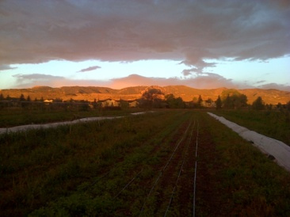 | Neighborhood Council Meeting Initial Planning Session  9/24/2016  9:00 AM to 10:55 AM  Brook's House  2907 Radcliff Cir. 970-492-5298
Meeting called by: |  | Type of meeting:
Facilitator: |  | Note taker:
Timekeeper:
Attendees:
Please read:
Please bring:
----- Agenda Topics -----
Opening Vision Board |  | Dhara | 5
Stephanie's report of conversation with Seth just following the community meeting |  | Dhara for Steph | 15
Reading of the Citizen Engagement Documents |  | Shared | 15
Zoning, Density & Compatibility Codes |  | Brook | 15
Flood Plain issues/Mickey Report |  | Phil | 15
Letter to the Editors in the Coloradoan |  | Steve | 15
Develop Initial tasking timeline |  | shared | 15
Gerry Horac/Neighborhood Meeting |  | Dhara | 10
Neighborhood Survey |  | Dhara | 5
Set next meeting date/location |  | shared | 5
Other Information
Resource persons:
Special notes:

Neighborhood Council Meeting Initial Planning Session

9/24/2016
9:00 AM to 10:55 AM
Brook's House
2907 Radcliff Cir. 970-492-5298
Meeting called by: |  |  | Type of meeting:
Facilitator: |  |  | Note taker:
Timekeeper:
Attendees:
Please read:
Please bring:
---------- Agenda Topics ----------
Opening Vision Board |  |  | Dhara |  | 5
 | Discussion:
 | Conclusions:
 | Action items: |  |  | Person responsible: |  | Deadline:

Stephanie's report of conversation with Seth just following the community meeting |  | Dhara for Steph |  | 15
 | Discussion:
 | Conclusions:
 | Action items: |  | Person responsible: |  | Deadline:

Reading of the Citizen Engagement Documents |  | Shared |  | 15
 | Discussion:
 | Conclusions:
 | Action items: |  | Person responsible: |  | Deadline:

Zoning, Density & Compatibility Codes |  | Brook |  | 15
 | Discussion:
 | Conclusions:
 | Action items: |  | Person responsible: |  | Deadline:

Flood Plain issues/Mickey Report |  | Phil |  | 15
 | Discussion:
 | Conclusions:
 | Action items: |  | Person responsible: |  | Deadline:

Letter to the Editors in the Coloradoan |  | Steve |  | 15
 | Discussion:
 | Conclusions:
 | Action items: |  | Person responsible: |  | Deadline:

Develop Initial tasking timeline |  | shared |  | 15
 | Discussion:
 | Conclusions:
 | Action items: |  | Person responsible: |  | Deadline:

Gerry Horac/Neighborhood Meeting |  | Dhara |  | 10
 | Discussion:
 | Conclusions:
 | Action items: |  | Person responsible: |  | Deadline:

Neighborhood Survey |  | Dhara |  | 5
 | Discussion:
 | Conclusions:
 | Action items: |  | Person responsible: |  | Deadline:

Set next meeting date/location |  |  | shared |  | 5
 | Discussion:
 | Conclusions:
 | Action items: |  |  | Person responsible: |  | Deadline:
Other Information
Resource persons:
Special notes:

